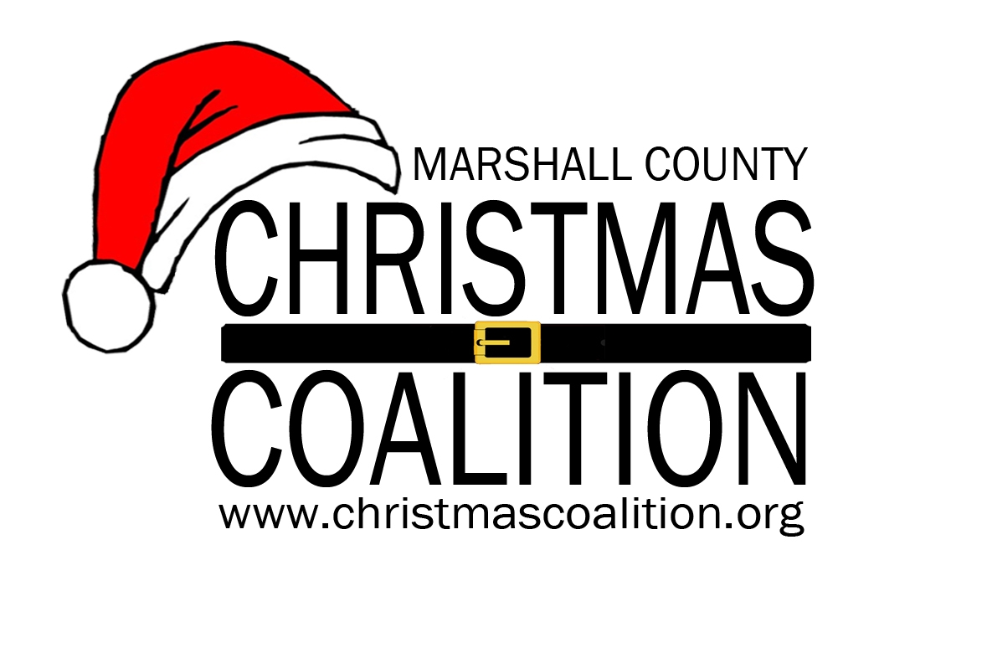
Marshall County Christmas Coalition
P.O. Box 71 * Guntersville, AL 35976
Phone 256-582-9998 *
christmascoalition@gmail.com
www.christmascoalition.org

ITEMS MUST BE BROUGHT TO THE GIFT DISTRIBUTION SITE ON
DECEMBER 8th – 10th FROM 8:00 a.m.- 4:00 p.m.

IF YOU DO NOT WISH TO SPONSOR A CHILD(REN) BUT WOULD LIKE TO MAKE A MONETARY DONATION, PLEASE MAIL TO THE ABOVE ADDRESS.

SPONSOR’S NAME: ___________________________________________________________

CONTACT PERSON: ___________________________________________________________

ADDRESS: _______________________________________________________________

_______________________________________________________________

TELEPHONE NUMBER(S) - Daytime_______________________________________________

EMAIL ADDRESS: _____________________________________________________________

NUMBER OF CHILDREN TO BE SPONSORED: _____________________

SPONSORSHIP PREFERENCE:
_____ NO PREFERENCE

_____BOYS _____5& UNDER _____6-12 _____13-18

_____GIRLS _____5& UNDER _____6-12 _____13-18

*We will do our best to honor your preference, but we do not split families.

GEOGRAPHIC PREFERENCE:
____NO PREFERENCE ____ALBERTVILLE ____ARAB ____ASBURY

____BOAZ ____DOUGLAS ____GRANT

____GUNTERSVILLE ____UNION GROVE

*We will do our best to honor your preference, but we cannot make any guarantees.

You will receive complete instructions about where to take the gifts when you receive information about the child(ren) assigned to you.

